**Experiment No. 1.1**

**Student Name:** Gaurav Kumar  **UID:** 22MCC20177

**Branch:** MCA **–** CCD **Section/Group:** MCD-1/ Grp A

**Semester:** III **Date of Performance:** 15th Sept 23 **Subject Name:** CONTAINERIZATION **Subject Code:** 22CAH-742

WITH DOCKER

**1. Aim/Overview of the practical:**

1. Install Docker on Linux or windows.
2. Using docker CLI with commands.

**2. Code for practical(a): Installing Docker on Windows**

1. Go to the website https://docs.docker.com/docker-for-windows/install/ and download the docker file.
2. Note: A 64-bit processor and 4GB system RAM are the hardware prerequisites required to successfully run Docker on Windows.
3. Then, double-click on the Docker Desktop Installer.exe to run the installer.
4. Note: Suppose the installer (Docker Desktop Installer.exe) is not downloaded; you can get it from Docker Hub and run it whenever required.
5. Once you start the installation process, always enable Hyper-V Windows Feature on the Configuration page.
6. Then, follow the installation process to allow the installer and wait till the process is done.
7. After completion of the installation process, click Close and restart.
8. **Code for practical(b): Start Docker Desktop Tool**
   1. After the installation process is complete, the tool does not start automatically. To start the Docker tool, search for the tool, and select Docker Desktop in your desktop search results.
   2. Before starting the application, Docker offers an onboarding tutorial. The tutorial explains how to build a Docker image and run a container.
   3. You are now successfully running Docker Desktop on Windows.
   4. Next, follow the instructions below to install the Docker engine on your system.
   5. Go to Docker CLI and run the Docker version to verify the version of Docker installation on the system.
   6. Congratulations, Docker Installation on Windows is now done, and now, you are ready to build and run Docker images and containers on the Docker ecosystem.

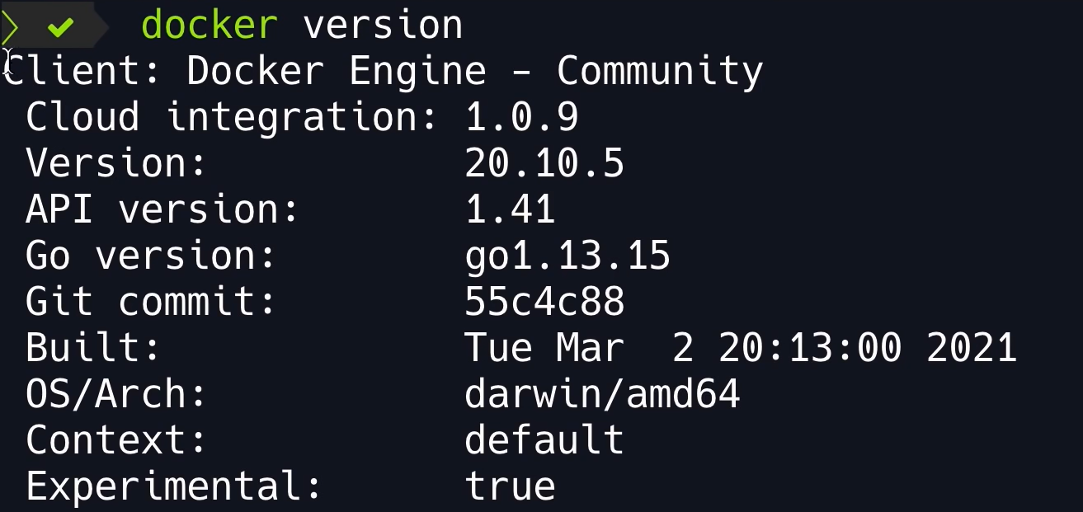

1. **Code for practical(c): Using docker CLI with commands.** 
   * docker ps: List all running containers.
   * docker images: List all images.
   * docker run: Run a container.
   * docker stop: Stop a container.
   * docker rm: Remove a container.
   * docker build: Build an image.
   * docker push: Push an image to a registry.
   * docker pull: Pull an image from a registry.